**NETWORKING PROJECT 1**

**Enterprise Multi-Site Network Design Using Cisco Packet Tracer**

**-SAI VIGNESH KUMAR**

**Project Overview:** The project demonstrates the designing and implementation of a multi-site enterprise network using Cisco Packet Tracer. The network simulates the real world enterprise environment with multiple VLAN’s, dynamic routing, security controls, and device hardening.

**Key Technologies:**  There are certain technolgies used.

* VLAN and inter-VLAN routing.
* OSPF (Dynamic Routing)
* ACL’s
* NAT/PAT
* DHCP
* STP
* SSH hardening.

1. **Network Design and Planning:**
2. **Logical Topology:** It consists of two topology sites, A and B. Each site consists of a router, Layer 2 switch, Multiple PC’s. Routers are connected via a WAN serial link.
3. **VLAN And IP addressing:** There are 3 departments HR, IT, Finance and the IP adddresses are:
4. VLAN 10 HR DEPT -> 192.168.10.0/24
5. VLAN 20 IT DEPT -> 192.168.20.0/24
6. VLAN 30 Finance DEPT -> 192.168.30.0/24

* The common WAN network IP address -> 10.0.0.0/30

1. **Physical Topology and Setup:**

* **Step 1:** Open Cisco Packet Tracer and drag and place 2 routers, 2 switches and end devices. Connect PC to Switch , Switch to Router using Copper straight through cable and Router to Router using Serial DCE cable.

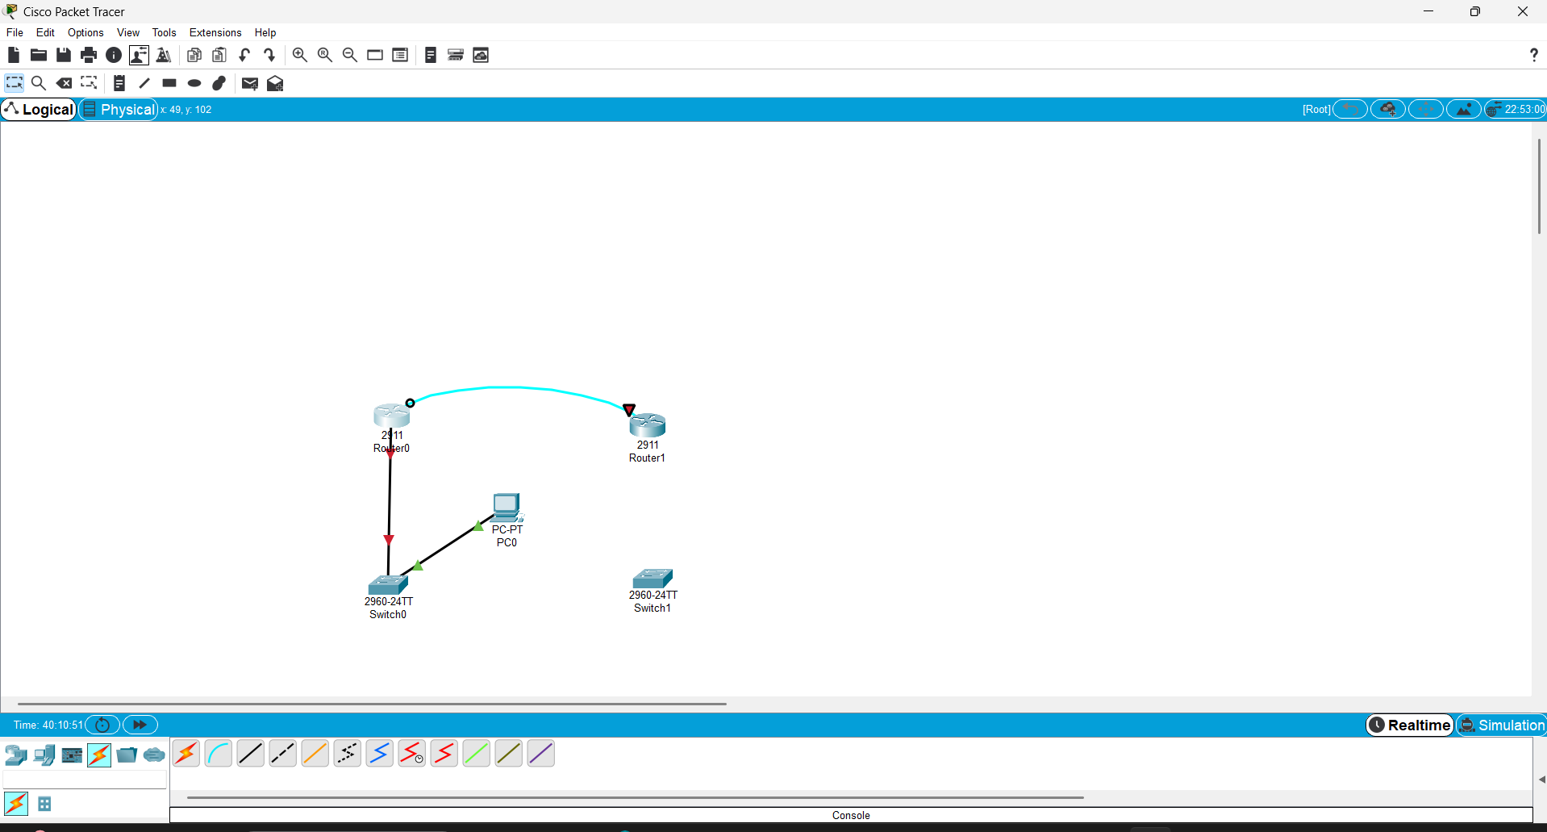

* **Step 2:** Connect router 0 to router 1 using serial 0/0/0 cable, DCE provides clock rate and DTE recieves clock rate. Then configure router 0 and router 1 by typing the commands.
* **Router 0:**

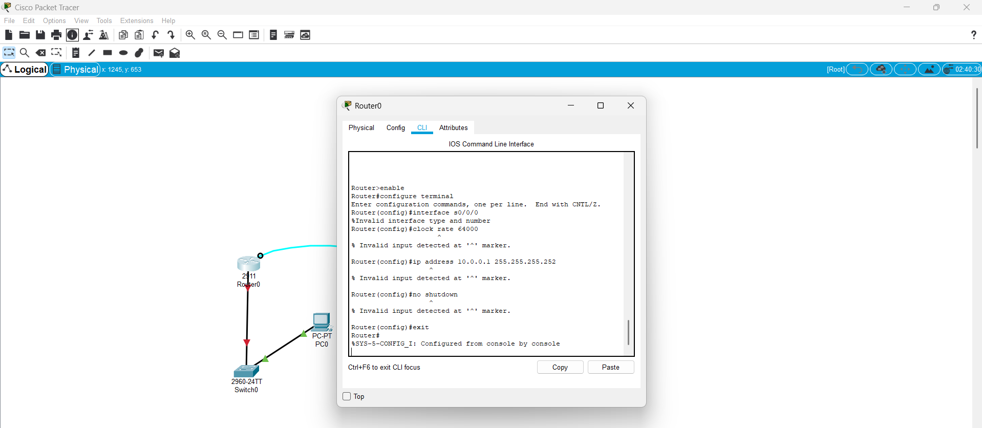

* Router 0 acts as CLI commands for DCE connection.
* **Router 1:**

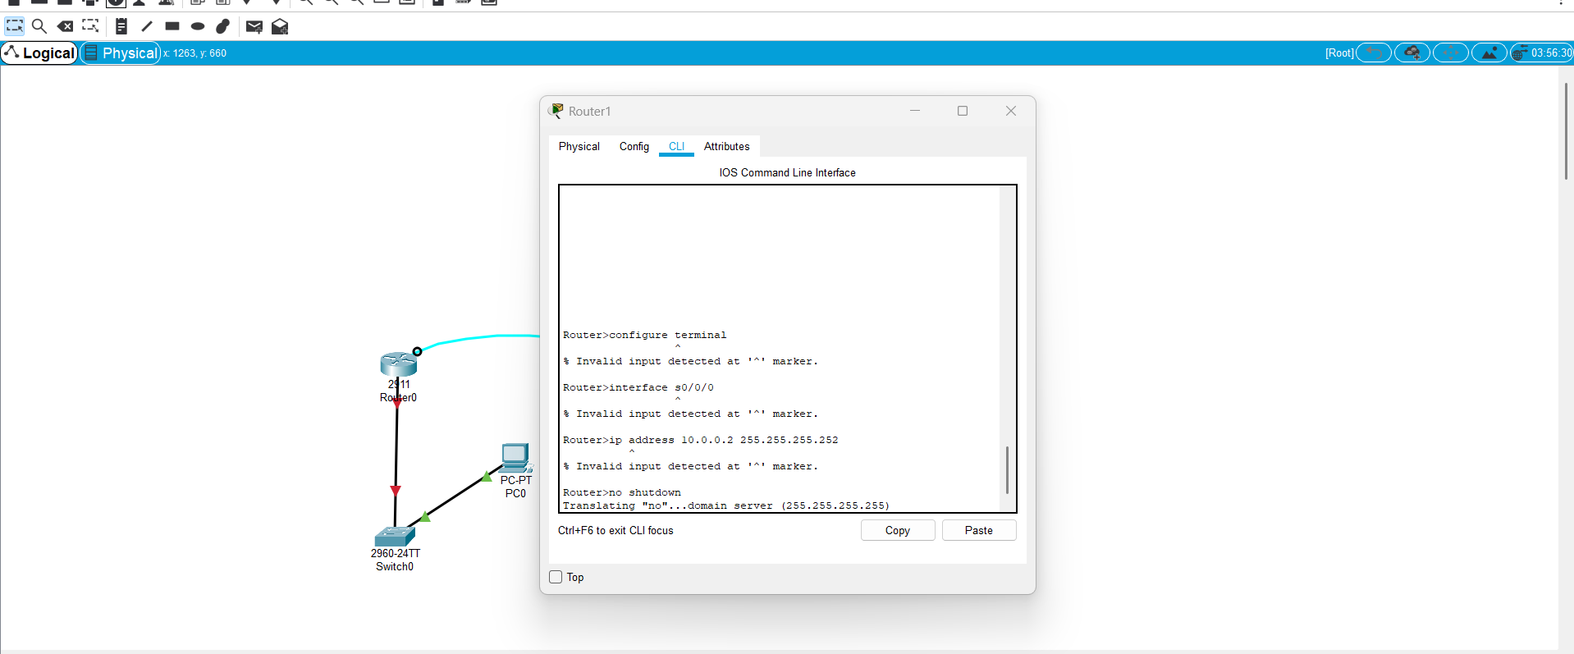

* Router 1 acts as CLI commands for DTE connection.
* **Step 3:** Enable VLAN configuration on switch on VLAN 10, VLAN 20, VLAN 30 for HR, IT and Finance departments.

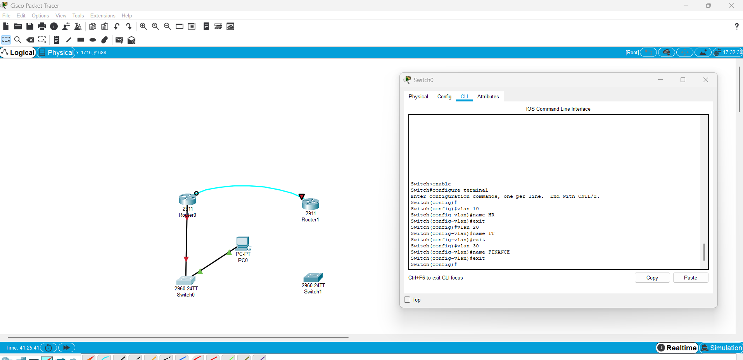

Now assign Fa0/1 to VLAN 10, Fa0/2 to VLAN 20 and Fa0/3 to VLAN 30 as shown, and type the following commands.

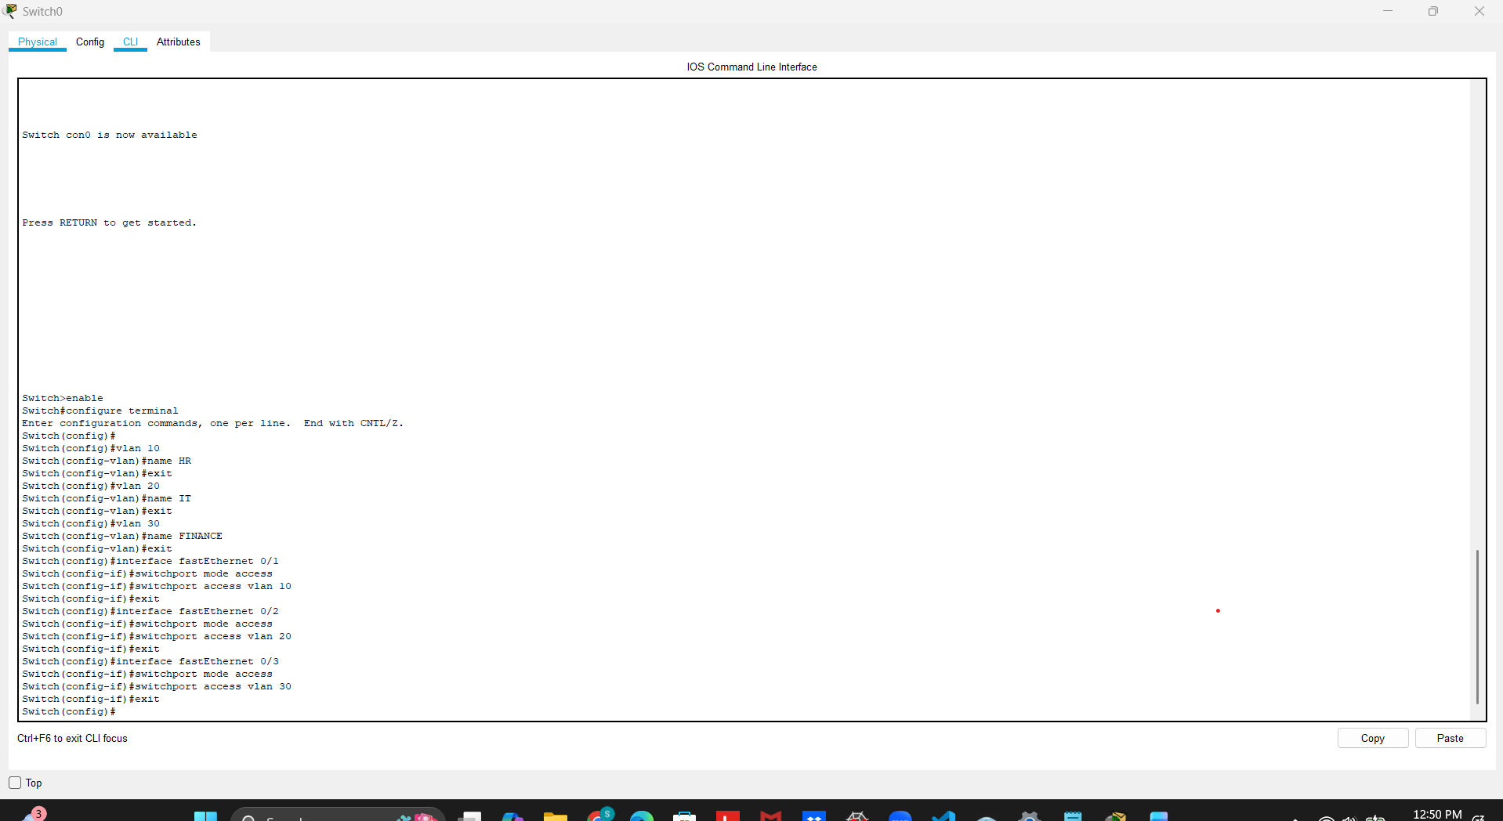

* This screenshot shows that the ports are assigned to the 3 departments with the FastEthernet 0/1, 0/2, 0/3 for Vlan’s 10,20,30.
* **Step 4:** Now we can see the VLAN configuration and output screenshots for FastEthernet 0/1, 0/2, 0/3 and the VLAN active status for all the departments.

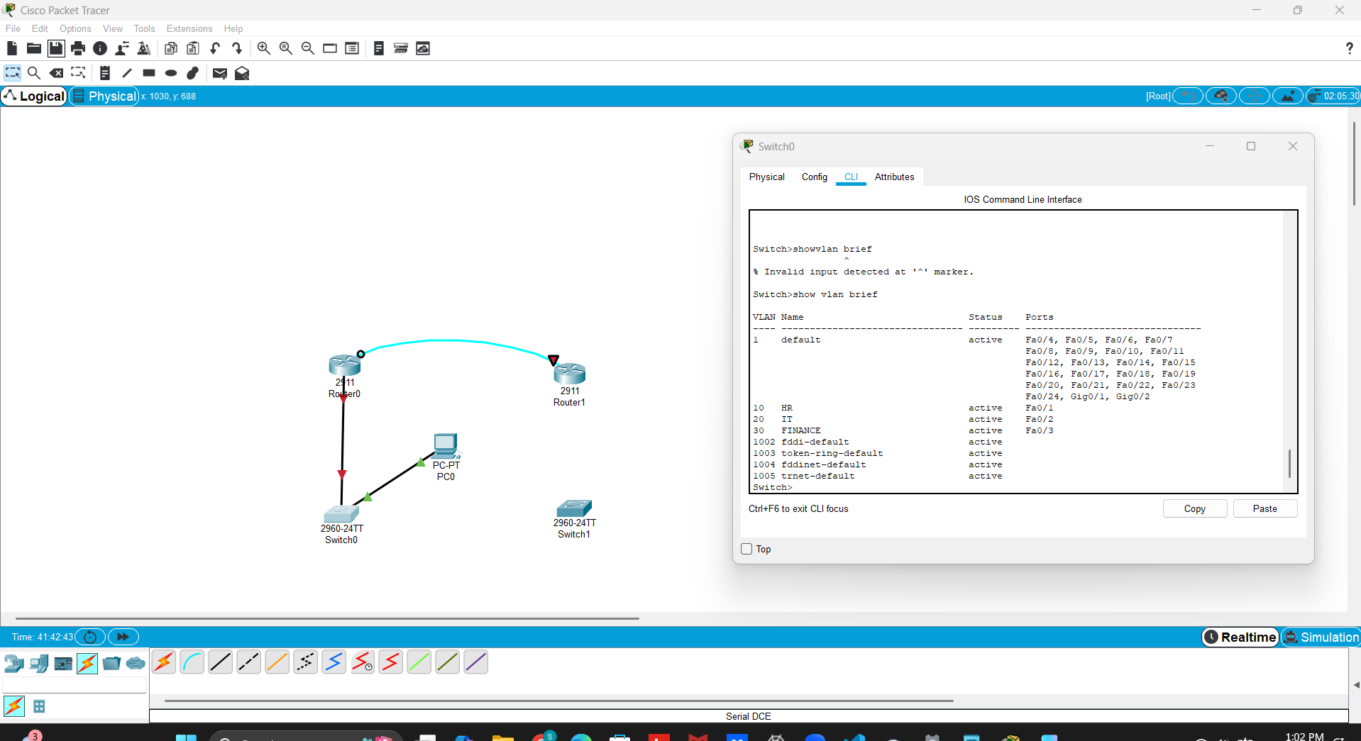

* **Step 5:** Now proceed with the trunk configuration, which enables VLAN traffic between the switch and the router.

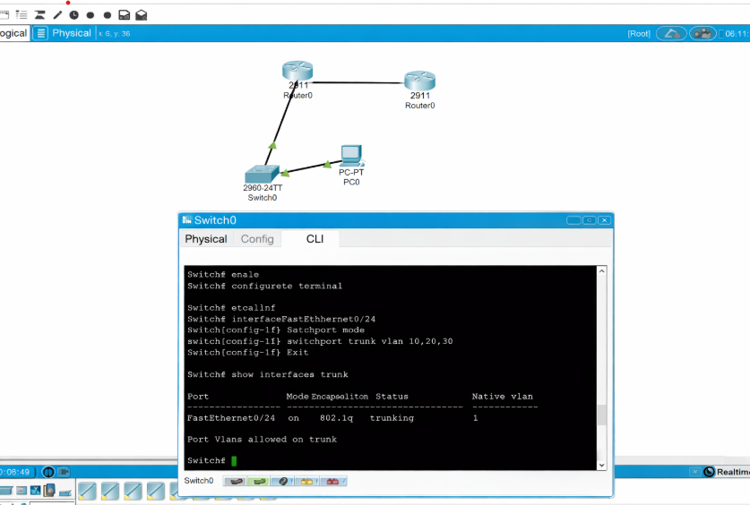

After prepare router interface by enabling Router0 CLI command.

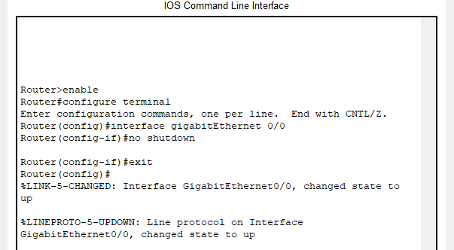

Now you should see switch trunk configured, router interface enabled and trunk verified status as shown.

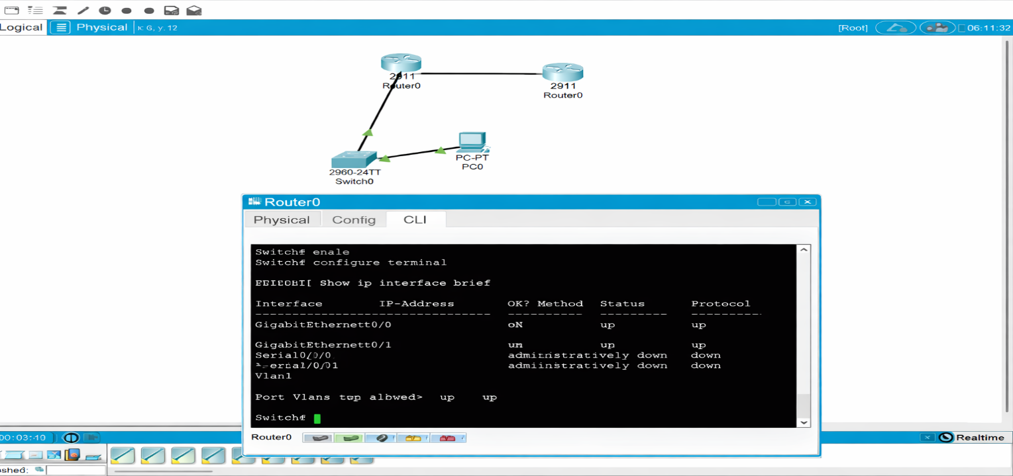

* **Step 6:** The next is the Inter VLAN routing commands. (Router on a stick)

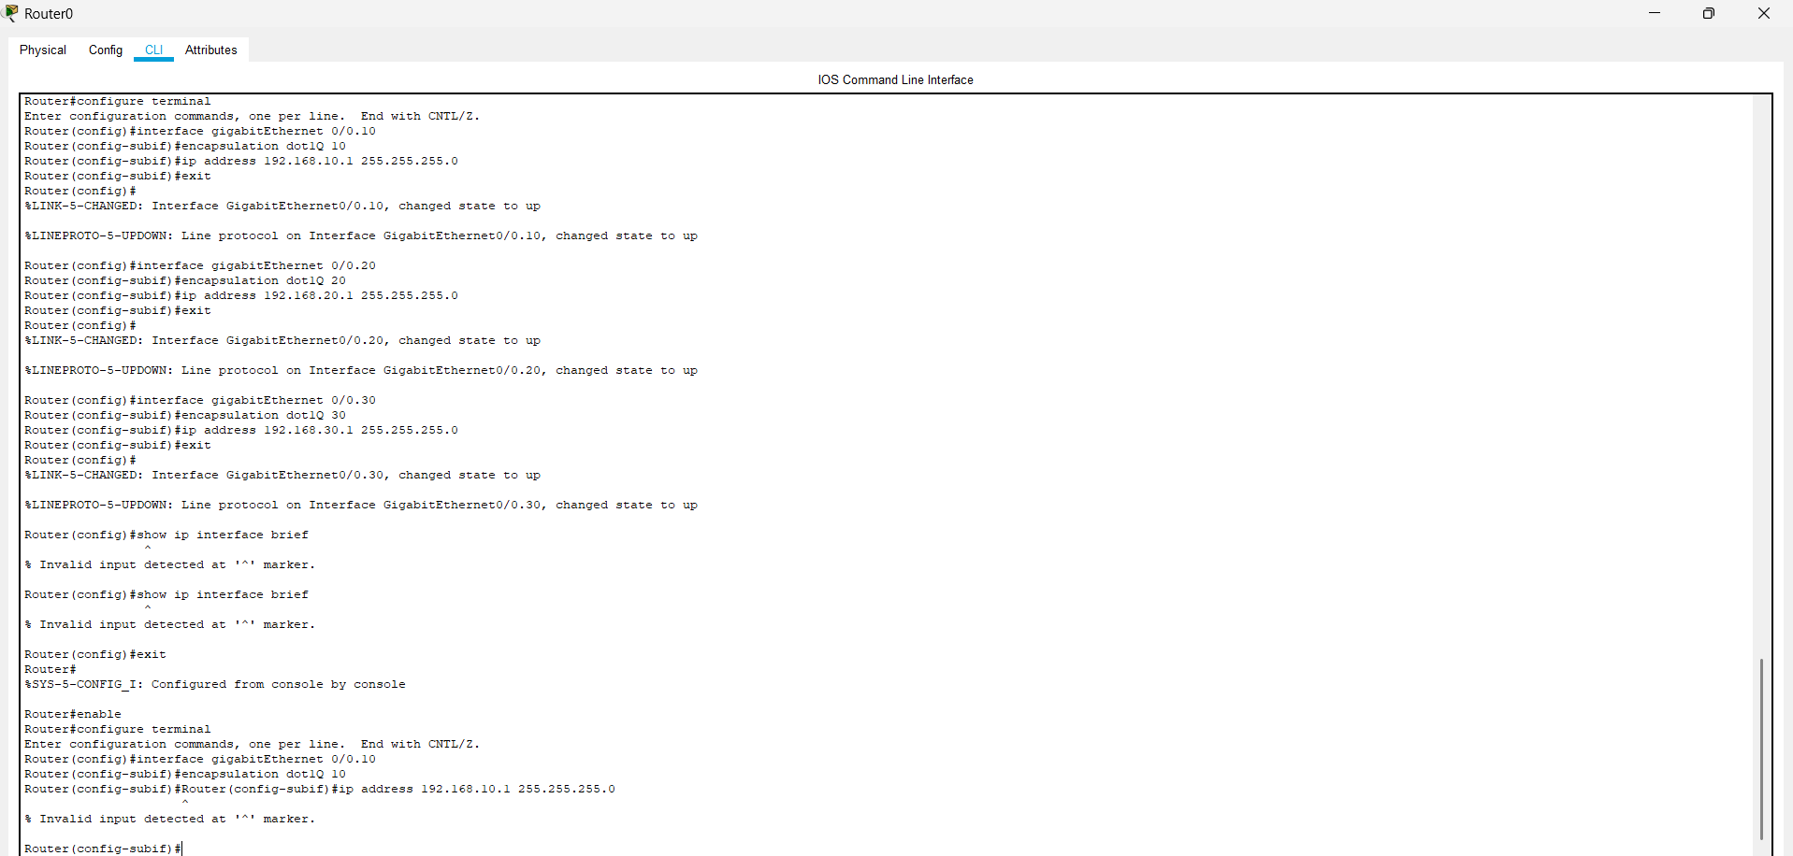

If we verify the configuration we will see the physical router interfaces with multiple interfaces.

* **Output:**

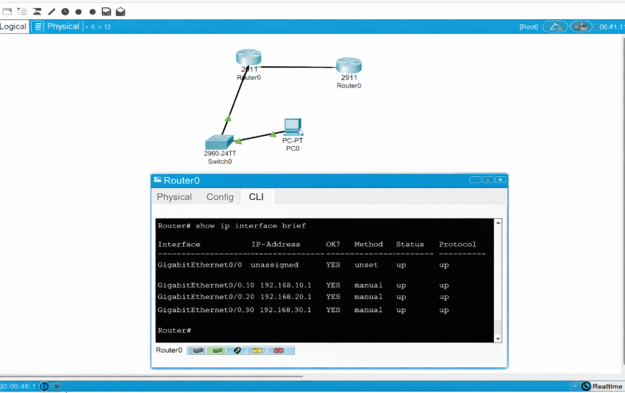

* **Step 7:** To enable DHCP connection over the network on Router 0.

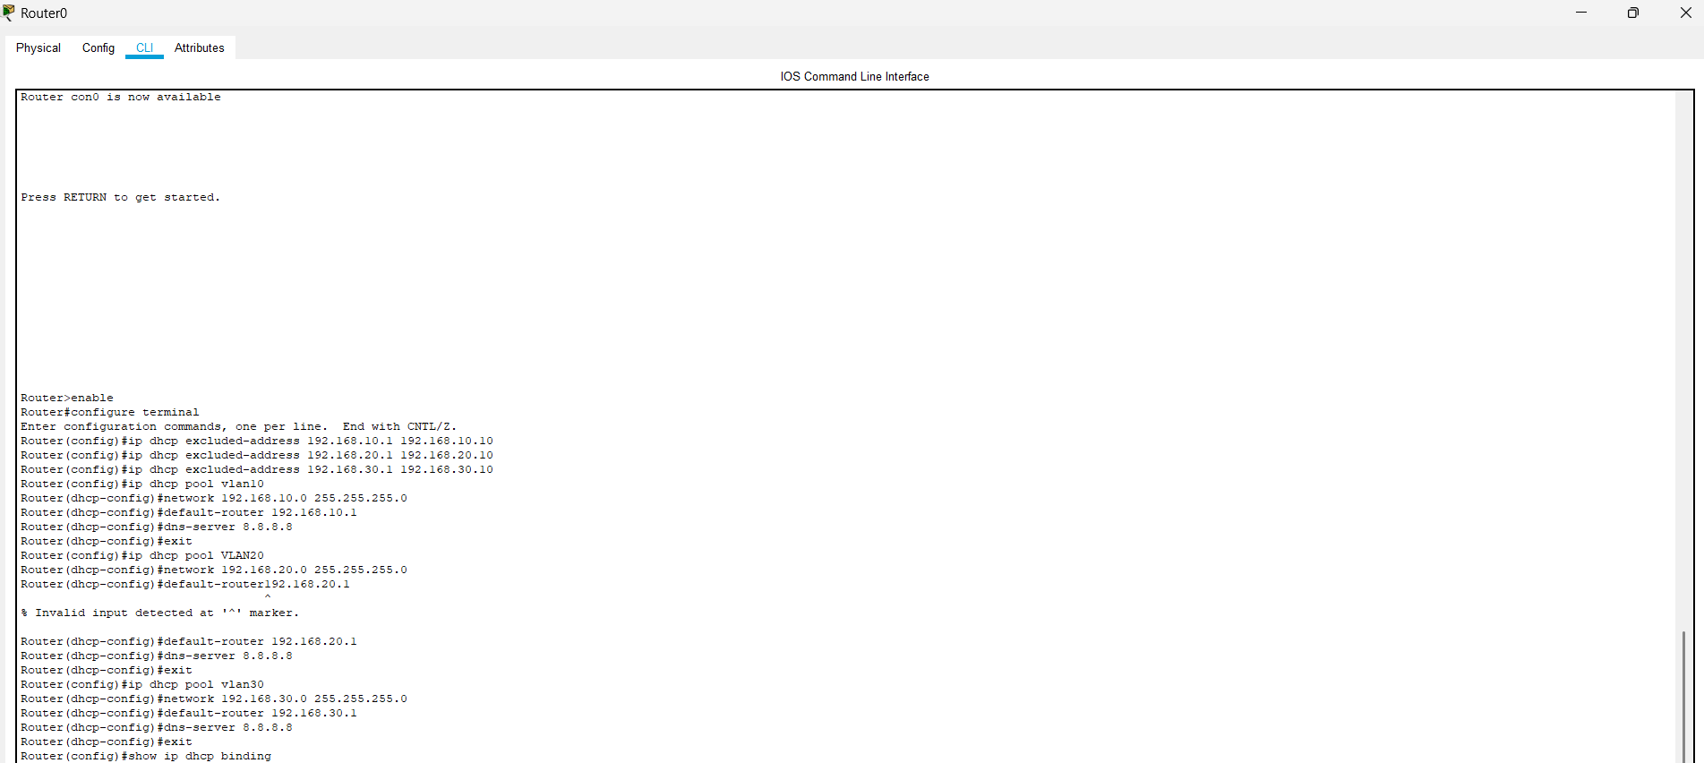

The screenshot shows the IP binding for the client address.

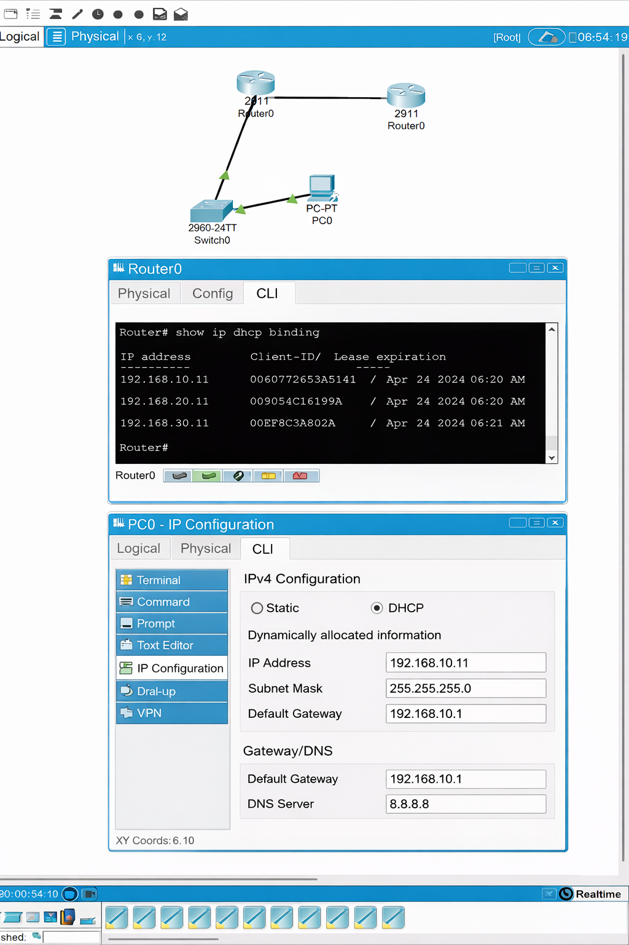

* **STEP 8:** Connect router 0 to router 1 and configure WAN link. Enable OSPF connection on both the sides.

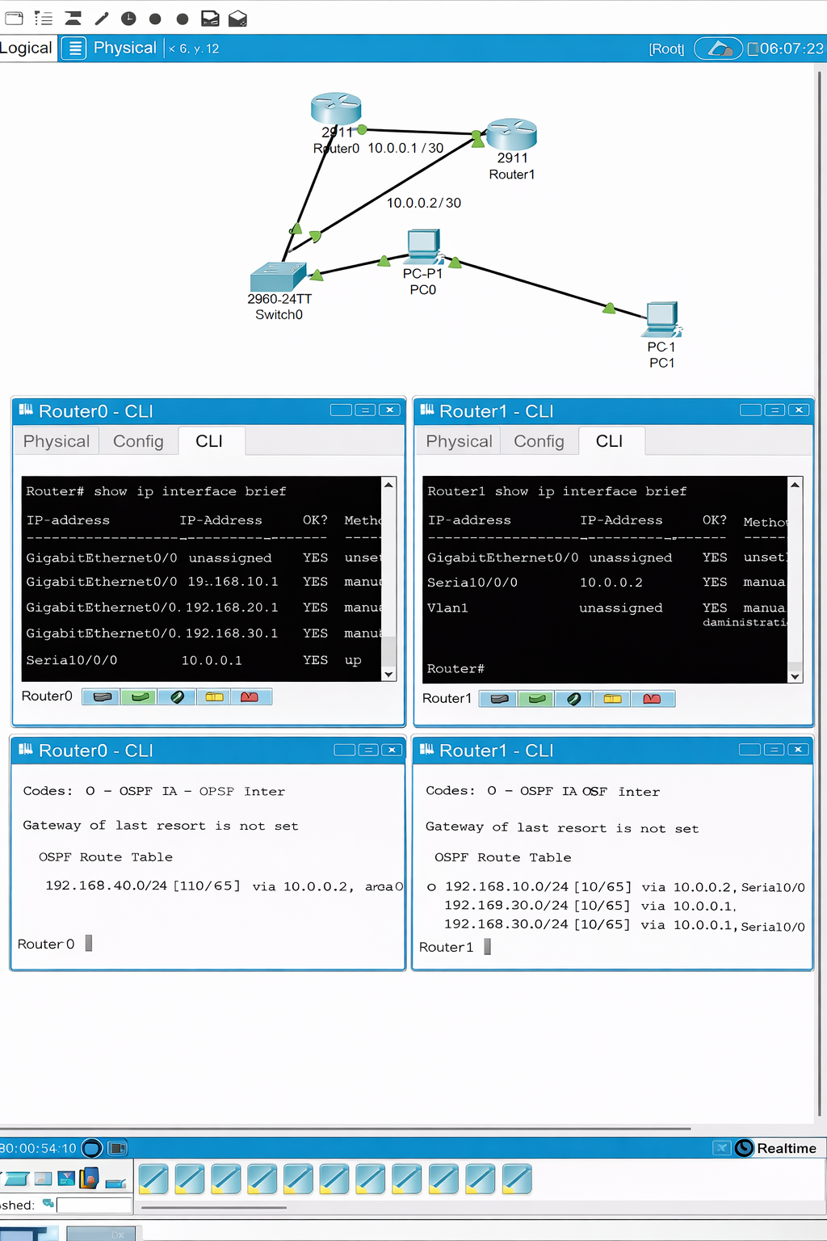

IP address configuration: router 0 -> 10.0.0.1/30 and router 1 -> 10.0.0.2/30. Enabling OSPF connection automatiically changes to routing information.

* **Step 9:** The next enabling OSPF dynamic routing between the sites to ensure the secure connection between the network.

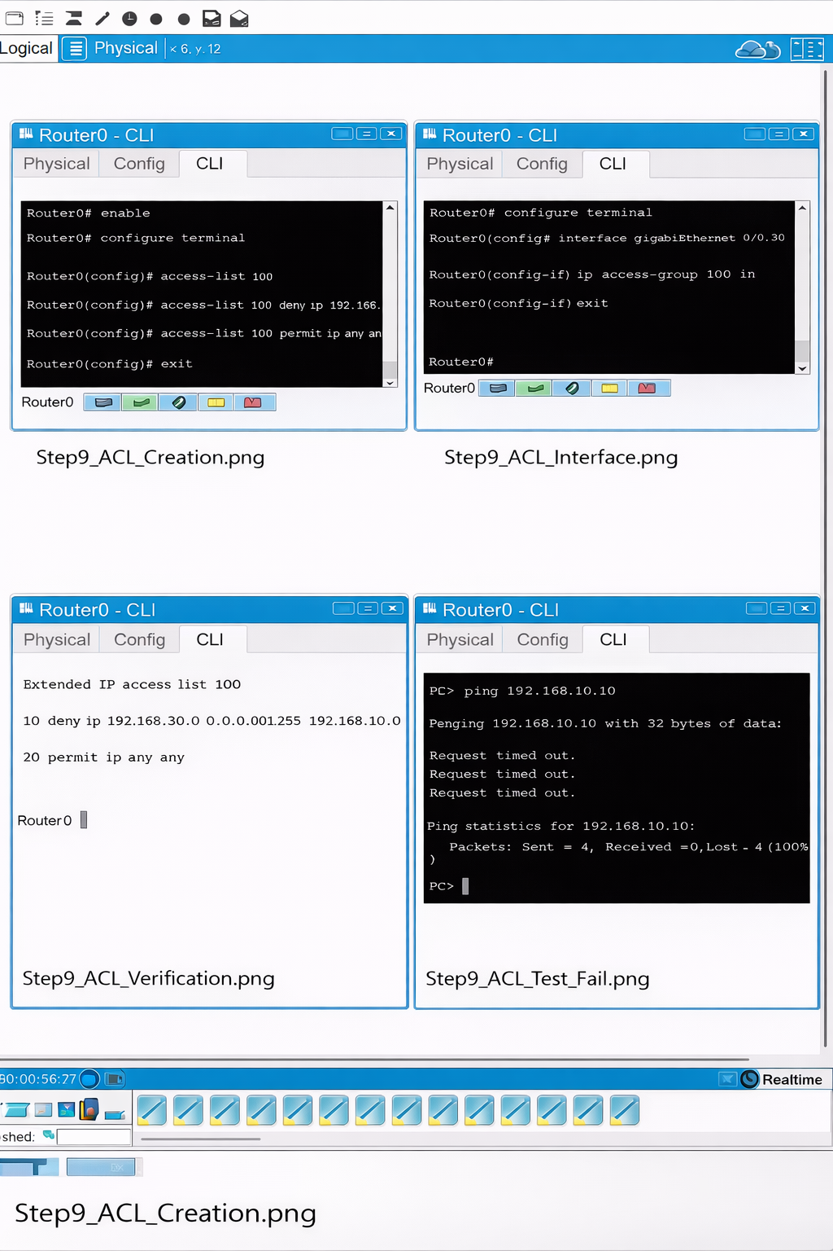

* The Features: It controls who is allowed to communicate to the server.
* It blocks unathorized inter VLAN network.
* It implements real enyterprise access network.

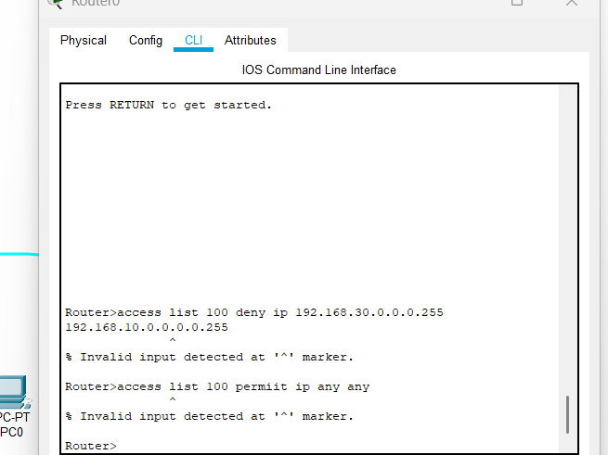

It implements the ACL’s on router to restict unauthorised inter VLAN communication. I blocked Finance VLAN traffic from accessing HR VLAN while allowing other traffic, demonstrating enterprise level network security control.

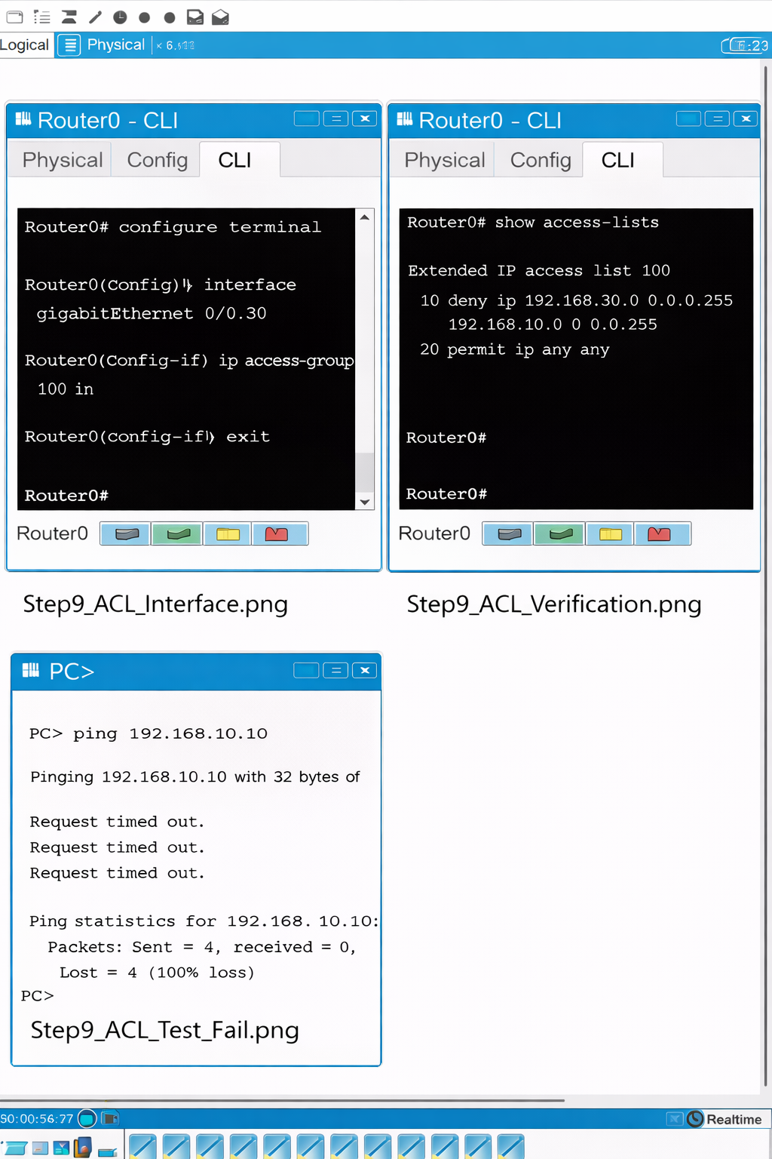

I applied ACL inbound to router, which allows VLAN 30 against ACL 100, traffic rules are correctly listed and router is enforcing security policy.

* **Step 10:** Then block HR VLAN from finance VLAN and apply ACL’s.

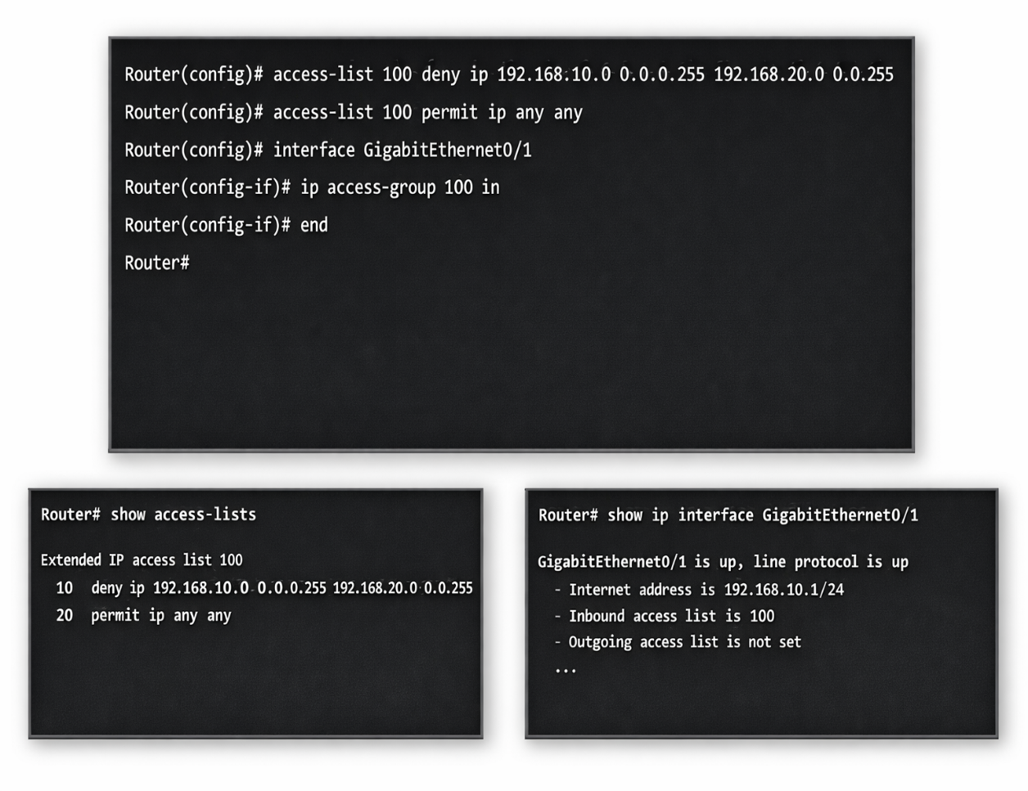

The line creates standard ACL 100 that blocks any traffic from HR VLAN to Finance VLAN. This allows other traffic is allowed. This applies ACL 100 inbound on the HR VLAN interface, so all traffic coming from HR is filtered according to the ACL.

* **Step 11:** After configure STP for Loop prevention. Its access phase request formm one interface to other interface configuration. Enter the ip configuration commands for the DHCP assigning routers.

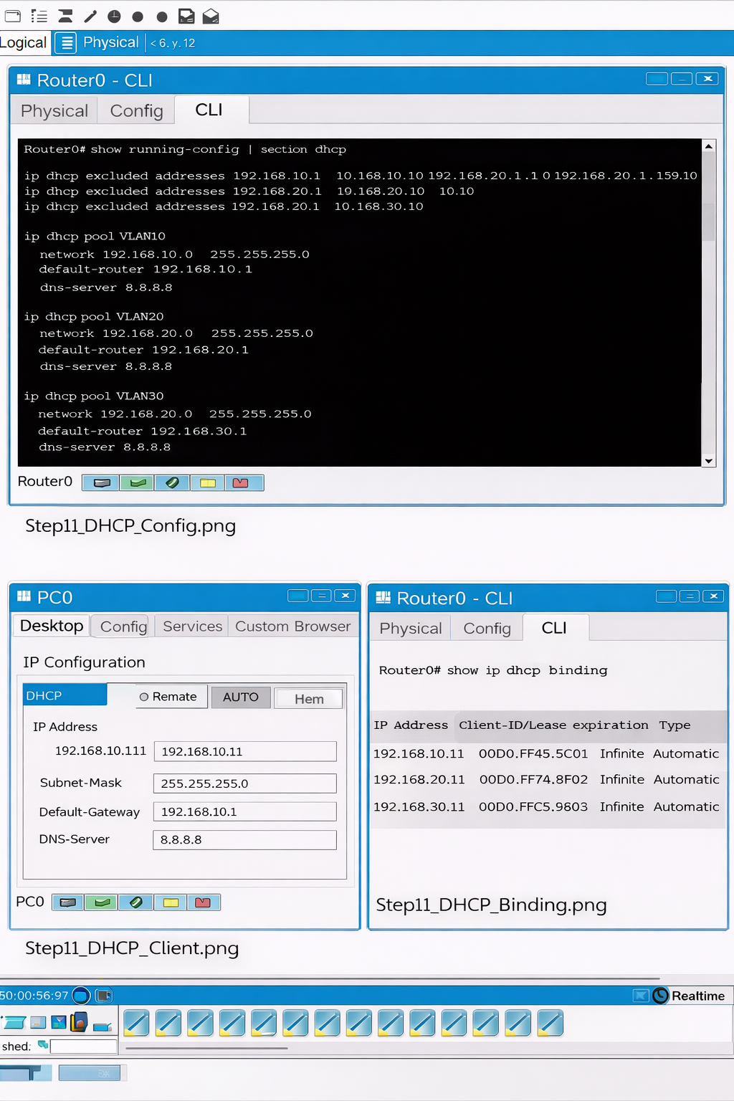

Create a DHCP pool for VLAN’s 10,20,30 and the binding table, Pc sends DHCP Discover router accepts and PC respondsand Router configures the commands.

* **Step 12:** Next is the Spanning Tree protocol, which prevents switching loops and improves stability. STP is used to prevent Layer 2 loops, avoid broadcast stroms, and ensure network stability.

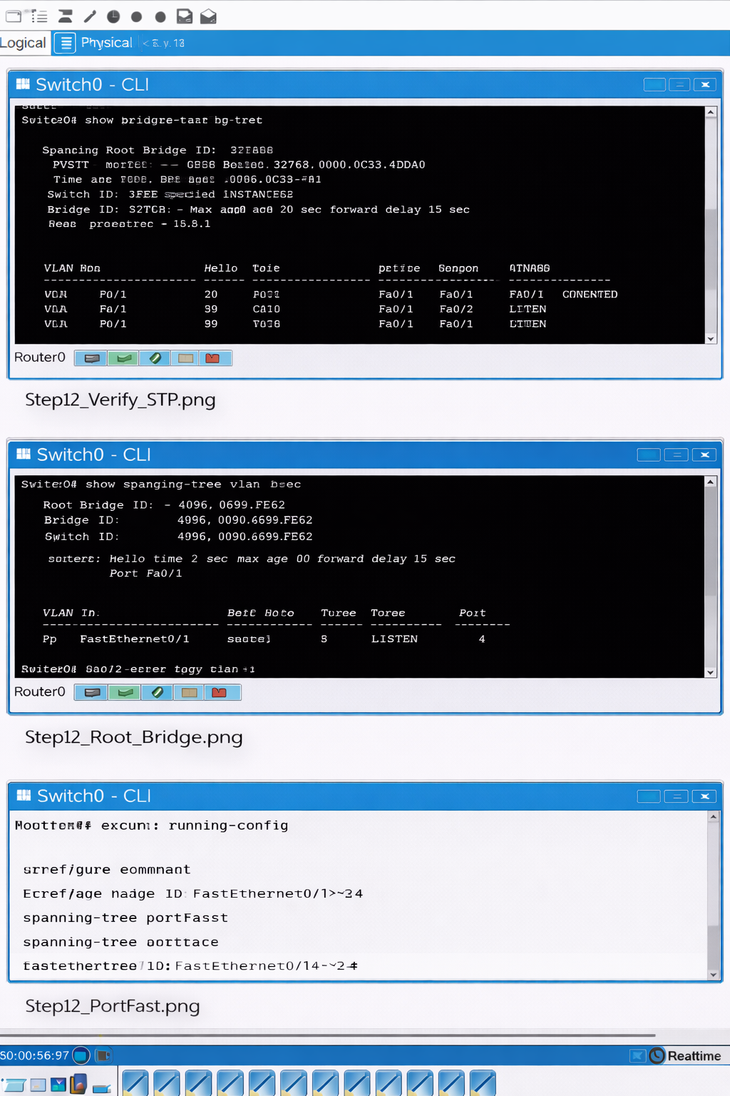

* **Step 13:** The next is the ssh hardening for secure remote access over the network protocols. It will replace telnet with ssh server. The device generates cryptographic keys and authenticated users can access device securely.

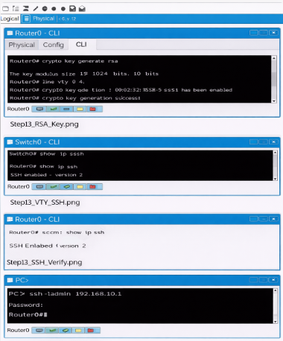

You are securing the remote access to the network device, the device access could be insecure. The router generates RSA cryptographic keys and used to encrypt ssh sessions, router uses local username and password and telnet disabled.

* **Step 14:**  The final testing and validation is needed.

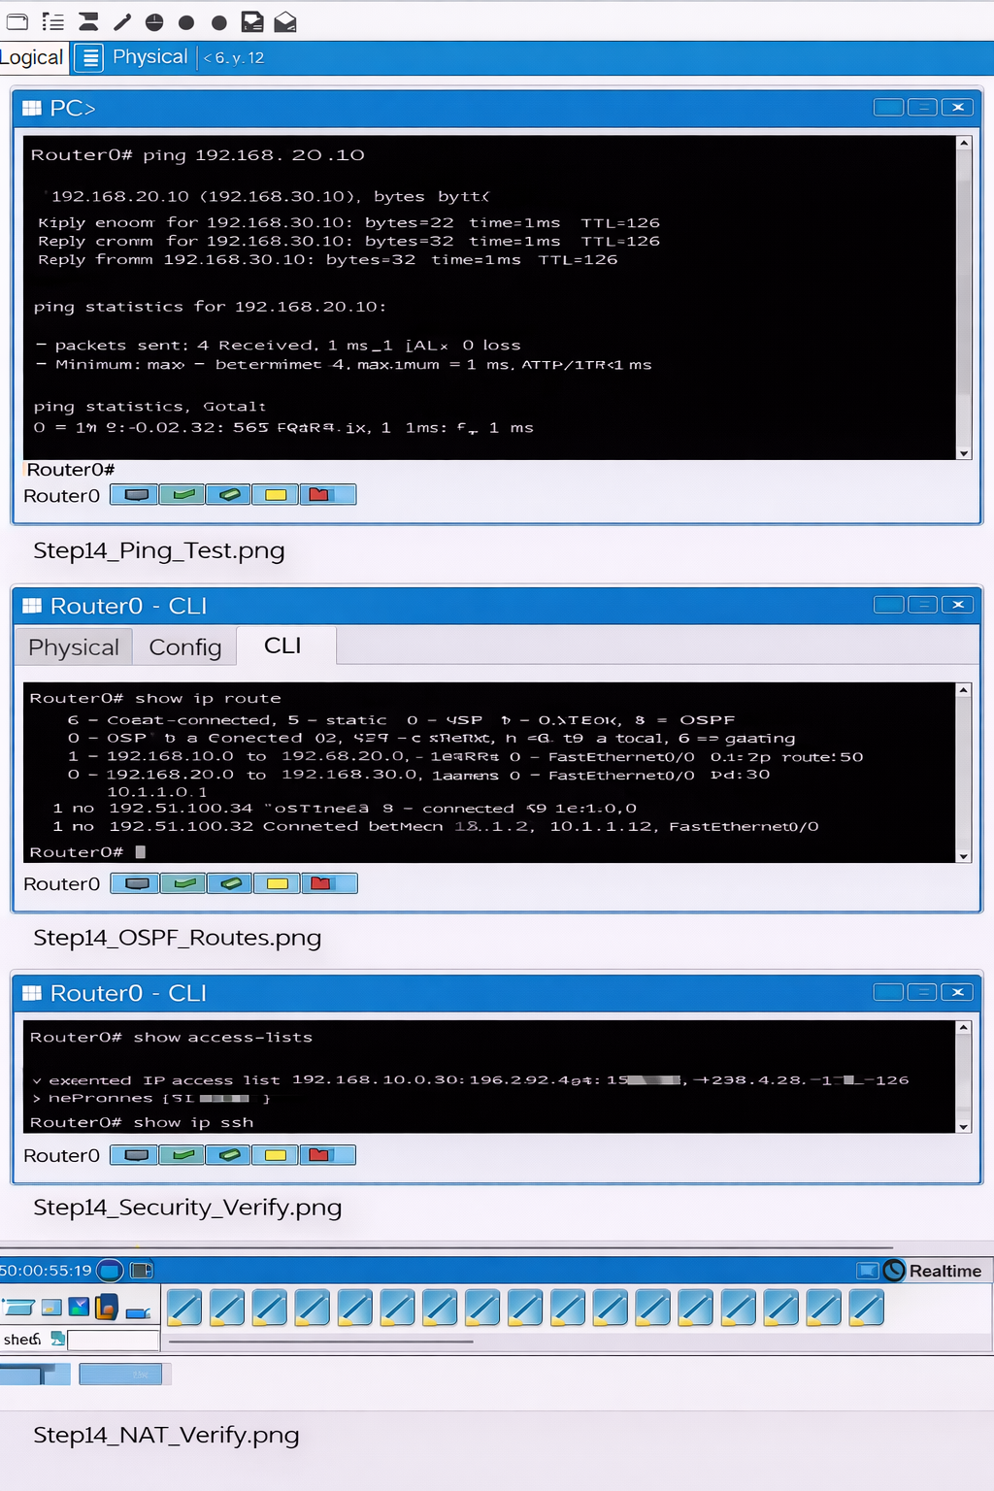

* **Conclusion:** This project successfully simulates a real-world enterprise multi-site network with secure routing, segmentation, and management.